Church Repairs Now and Then: Shelford Church in 2016 and 1842
John Fisher
The maintenance and repair of churches is a never-ending story, the latest episode in which, at St Peter and St Paul’s Shelford, Nottinghamshire, began in 2013. The problem was first identified by Bruce Bradley, of Peart Bradley Architects, in a Quinquennial Report on the state of the Church fabric in 2013: the roof of the Church tower was in need of repair. The threat was realised in the next year when rainwater came into the Bell Chamber. Andrew Mills, the chief bellringer and the new churchwarden in 2015, was able to effect temporary repairs, but it was evident that more substantial action would be needed. After several frustrating delays, work began on the tower roof of Shelford Church in January 2016, as a matter of some urgency.
The repair of course had to be paid for. Mr Bradley estimated that it would cost some £30,000, a sum that would severely deplete if not overwhelm the Church’s Fabric Fund. When work eventually began in January 2016, a further problem was found: the timber in the roof of the Bell Chamber had rotted through. This required a further £7,000. In the event, Mrs Eileen Smith, of the Fabric Committee of the Parochial Church Council, took the initiative in raising funds: after a (surprising) failure to win an allocation from the Listed Places of Worship Roof Repair Fund, a considerable sum came from a mixture of grants from trusts (and Rushcliffe Borough Council; see Appendix), community activities (Shelford Feast Weekend and visits from the Sealed Knot) and individual donations. The names of the various trusts will be on display when the roof repairs are completed.

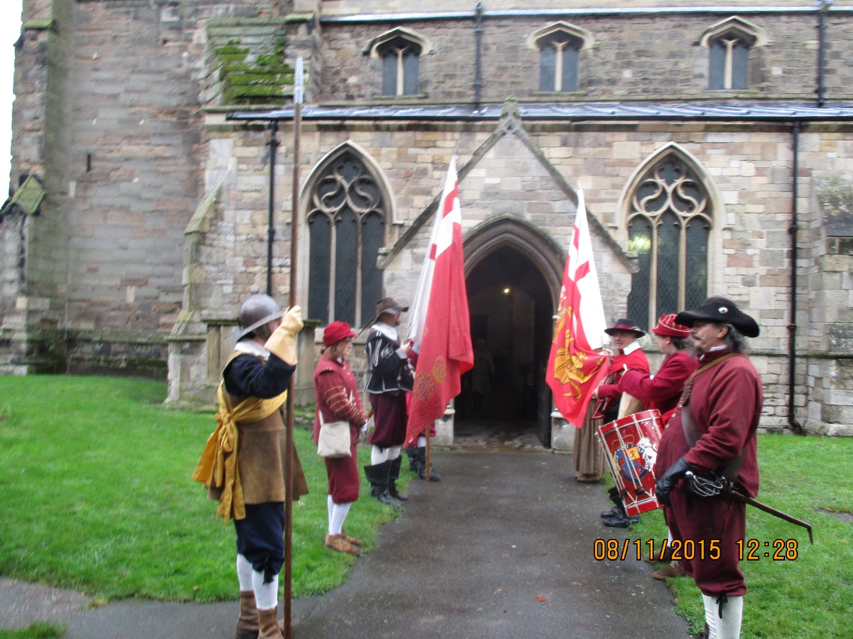
The Sealed Knot at Shelford Church
One notable absentee from the list of donors was the Crown Estate. An appeal to the Estate was rejected by the head of the Rural Division, a Mr K Jones, on the specious grounds that the church was not actually on estate land. This might be true, but the rejection flew in the face of past practice, and violated its duty under the Crown Estate Act of 1961. Under section 4(2), “the Commissioners may, out of the income of the Crown Estate, make contributions in money for any educational or religious purpose connected with land of the Crown Estate, or for other purposes tending to the welfare of persons residing or employed on any such land.” The Crown Estate had always seen fit to do this at Shelford ever since it acquired what is now known as the Bingham Estate, including virtually all of Shelford and Saxondale parishes, in the past. They no longer do so.
The refusal was also in marked contrast to the actions of the owner of the Estate before it fell to the Crown. By the mid-nineteenth century, the fabric of Shelford Church was deteriorating rapidly; the entry for Shelford in White’s Directory 1864 (p.372) described the church as `a venerable, but dilapidated edifice’. However, in the next decade, the then landowner, the Earl of Carnarvon, instigated and paid for the complete restoration of the church in honour of his recently deceased wife, Evelyn Stanhope, the sister and heir of the last Earl of Chesterfield to own the Estate. The restoration was undertaken by the leading expert of the day, Ewan Christian, and although Nikolas Pevsner disapproved of the final results, most other historians consider that Christian did an excellent job, retaining the main historical features and appearance of the Church.
The renovation of the whole Church in the 1870s was an extremely expensive operation, costing some £3,000 (equivalent to at least £500,000 in contemporary currency). It would have been well beyond the means of the local parish church community, as represented by the vestry and its churchwardens, with whom then lay the responsibility for repair and maintenance. As today, when the agents are the Parochial Church Council and the churchwarden, they undertook what measures they could – and paid for them. How they performed their duties, then and now, is the subject of the rest of this study.
The major focus is on Church repairs carried out in 1841 and 1842, a focus made possible by the discovery of a number of documents from that era, in September, 2015, in a metal container in the Stanhope Chapel. These included a set of notebooks and some loose invoices belonging to John Jallands, a substantial farmer at Water Lane Farm, Shelford, and one of two churchwardens serving from 1833 to 1854. The material in these, supplemented by other contemporary sources, makes it possible to reconstruct a fair picture of how they organised and paid for repairs to the Church in 1842. The essay concludes by comparing their actions then and those undertaken now in 2016 – a comparison that illustrates something of the major changes that have taken place between the two episodes.

England in the early nineteenth century was still, despite the advent of the Industrial Revolution, overwhelmingly a rural country. It was of course in the process of rapid change but life in villages like Shelford appeared much the same as ever. Most inhabitants had some connection to farming, although the community possessed a wide range of occupations and skills, and almost the whole parish was owned by an absentee great landlord, the Earl of Chesterfield. Nevertheless, by 1842, when the Illustrated London News, in one of its earliest numbers, published a short piece on Shelford Church, it was in its regular section on `Nooks and Corners of Old England’ – a village church was regarded as somehow antiquated. The church’s main claim to fame was as the burial place of the fourth Earl of Chesterfield although, as the writer acknowledged, his `Letters’ were `now rather talked of than read.’ And, even in Shelford, major developments were underway.
Just as today, the Church tower was the dominant feature in the parish landscape; it was described in the Illustrated London News of 1842 as having `a heavy solemnity in its appearance, it being wider than the nave’. So too did the Church of England superficially continue to pervade the life of the village. However, in 1840, the commencement of the building of a Primitive Methodist chapel marked a shift in the religious allegiance of many villagers. Other challenges to the established Church were also, if less salient, to arise during the rest of the century.

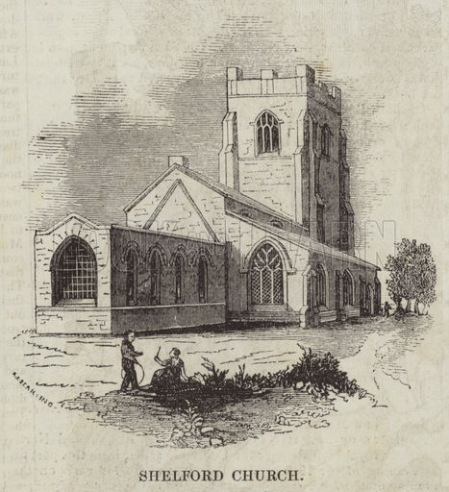
The Illustrated London News 20 August 1842.
This was less evident during the 1830s and 1840s; in fact, in what was an era of renewal in the Church of England generally, the church in Shelford lagged behind the times. The vicar, the Revd John Rolleston, a member of a leading local gentry family, for example, was an absentee and a pluralist (although, as no curate is listed in the Census, he presumably took at least some services). Although he resided nearby at his major living, in Burton Joyce, the vicar does not seem to have been a major presence in the village; the churchwardens’ accounts make frequent mention of the cost of letters to him. Nor, as was usual, was he the chairman of the vestry. Rather, the major figures, in a manner that ran parallel to the hierarchy in the social and economic life of Shelford village, were the two churchwardens and the vestry’s chairman.
The vestry in the 1840s, in association with the Justices of the Peace, was still the dominant institution in rural parishes. Some of its powers had been lost to the Boards established under the Poor Law Act of 1834, but it was still responsible for a range of clerical and secular matters. The vestry chairman was John Hassall, living at Shelford Manor, which had been previously occupied by junior members of the Earl of Chesterfield’s family, the Stanhopes. Hassall was the Earl’s agent on the Bingham estate, and farmed over 1,200 acres in Shelford and Saxondale parishes. In 1842, he was paying £2282 in rent (much higher than the average rent per acre in England and Wales in this era). The dominant personality at Shelford, he was, naturally enough, the parish’s representative on the Board of the new Bingham Poor Law Union. He was also a leading figure in the county, the regard in which he was held exemplified in the inscription recounting his virtues on a rebuilt Butter Cross in Bingham Marketplace (erected after his death in 1859).
After the 1836 Parochial Assessment Act, the two churchwardens who answered to him (previously it was to the local JPs) were John Pilgrim and John Jallands, two of the five large farmers in the parish. Pilgrim held nearly 400 acres, part in Shelford parish, part in Saxondale parish (having no church, the latter was included in Shelford parish for clerical and administrative purposes). He was a figure of some consequence as Head Constable for the Bingham Hundred. Jallands had some 200 acres in Shelford, and it is his notebooks and papers that furnish the primary material for this account.
The churchwardens looked after the day-to-day affairs of the Church: ordering communion wine, organising confirmations, buying new bell ropes and paying the bell ringers. They also paid the Parish Clerk, John Fisher, £4.11s.8d per annum on Lady Day, with additional sums for “washing the surplice” and “ Making the fier in the Stove” (the amount of coal ordered during the year indicates that this was for vestry meetings rather than church services; heating these is a feature of a later, more affluent age). The organist, John Wood (a cottager on 23 acres, but also a member of the vestry), was paid rather more: £6 per annum. The typical expenses, of some £20-30 in a year, were covered from a church rate they were authorised to raise as required. The rate was levied on land and fixtures, and was paid by the occupiers rather than owners of land, in Shelford essentially the tenant-farmers and cottagers on the estate. Two of Mr Jallands’ notebooks are devoted to lists of ratepayers and, after the Parochial Assessment Act of 1836, the amount of land held, the rent they paid and their assessment.
The usual rate was 2½d in the £, and had been collected in 1835, 1837 and 1841. In 1837, there were 47 ratepayers in Shelford and Newton, and another 10 from Saxondale (although 3 of these appeared in both lists in Mr Jallands’ notebooks). It is interesting to note that, in 1841, John Girton, the owner of the only piece of land not belonging to the Earl of Chesterfield, was assessed on 2 rods and 10 perches of land, with a value of £8 and yielding a rate of 1/8d. This was the land on which a beerhouse stood. Girton had already sold an adjoining plot to the Primitive Methodists, and they do not appear to have paid a rate – although they would certainly have been liable. The rate was levied on an occupier whether he (or she – women paid rates although, of course, they could not be on the vestry or be churchwardens) was a church or a chapelgoer, a source of much friction elsewhere. It does not seem to have been at Shelford; the only known Methodists who paid a rate were Edward Wakefield and Samuel Morley, cottagers on 8 and 9 acres respectively, who attended both church and chapel (a normal arrangement in many villages). But most Primitive Methodists in Shelford were landless labourers and therefore not subject to assessment.
By far the largest ratepayer was John Hassall, paying a rent of £2261/17/4d in 1841 and assessed for £21.17s.7d. Other large farmers paid £4-5 while a mass of cottagers paid 1-2s. `Lord Chesterfield’ was assessed to pay £1.14.10d for 52 acres, presumably on the plantations his pheasants were reared (Shelford was notoriously a game estate, visited only by its landlord for the shooting in autumn). Otherwise, the Earl (by 1841 becoming something of a recluse at Bretby, the family seat in Derbyshire) was as little involved as the vicar in these transactions.
In 1842, despite there having been a rate raised the previous year, it was decided to levy another. Where the initiative came from is unknown, but it seems likely to have been the chairman of the vestry. Further, at the last moment, it was also decided to raise double the amount. The original entry for the rate had been 2½d in the £; it was then crossed out and 5d substituted; the payments by occupiers were accordingly all doubled. The total raised in 1841 was £68.6s7d, while the church rate of 1842 raised £136.14s.9½.
The reasons for the increase were never stated but it is evident, from the loose bills and invoices included with John Jallands’ notebooks, and from the churchwardens’ reports to the diocese, that extensive repairs to the church fabric had been decided on. Interestingly, these were not fully reported to the diocese; the vestry took the responsibility on itself without others being involved (possibly not even the minister). Along with items such as a bill for a pair of `pulpit sconces’ (5s), and payments to a Mr Buckingham of Islington for tuning the organ, in 1841 and 1842, a series of invoices have been found in Mr Jallands’ notebooks, for building materials, for their transport and for their application.
In 1841, in April and May, Henry Ellis gave Jallands a bill for carrying 12 quarters of lime and 2 loads of sand. He also sought payment for the erection and dismantling of scaffolding at the church at a price of 5s. At the same time, William Swanwick sought payment for several barrels of “cement bar” (sic). Ellis was owed £2.5s 6d, Swanwick 4s.7d. In the same months, George Ball billed the churchwardens for “taking old stucoing (sic) of the walls repairing the plinth all round the Church and window sills with cement showing all round the Church showing all round the Church below the … Course and doing repairs in Church – sundries 7s and myself at diferent (sic) times £8.0.0”.
A year later, between July 23rd and August 1st, 1842, John Gilbert supplied quantities of `Yorkshire Stone’, costing £7.19s.4¼d. At much the same time, Isaac Hill supplied 600 bricks for 15s.7d. William Taylor, his son and another labourer, spent several days ”Flooring and Leviling the ground” and then “slating and flooring” before “whitewashing and cleaning” at a total cost of £8.9s.4d. Finally, in the same weeks, William Reason submitted his bill for “carpentry and supplies to pews and chairs” including “6 new seats with elbows and back railes and 2 with back framing” for £4.8.6d; “for fixing 2 candle sticks in the Pulpit” – 1.4d; “for paint to the sundial and puting up the stone” 10d, at a total cost of £21.19s.4d.
It should be noted that these bills were paid at various times between 1843 and 1845; presumably this reflected the speed at which the church rate was paid and money became available. These are just chance documents discovered in a package; there may have been others. Even so, it seems evident that what was undertaken was a `patch-up’ job at the church rather than the major renovation that it became evident was needed in a few years. That would be beyond the resources of the parish.
It is also interesting to note that most of the supplies came from and the work was generally undertaken by the inhabitants of Shelford and Saxondale. Both Henry Ellis, who farmed 110 acres (possibly at Holly Farm) and William Swanwick, with 13 acres, were listed as farmers in White’s Directory, although evidently they had other occupations (as was normal in nineteenth century villages). William Taylor was a villager in the 1841 Census while, of the two William Reasons, one was listed as a blacksmith (he was also in the Directory), the other as a carpenter. None of these were ratepayers. Isaac Hill was a brick and tile maker at Saxondale, paying a rate of 3.11½d on £19 of “House and Land”. The two other contractors, John Gilbert and George Ball, were from East Bridgeford and Bingham respectively. Finally, one of Mr Jallands’ bills recorded a payment of 3s to John Calah, identified as a bricklayer in the 1841 Census, for repairs to the Church walls. Shelford might be an agricultural parish but village life at the time perforce required a range of occupations and skills, ones that came into play when church repairs were required.

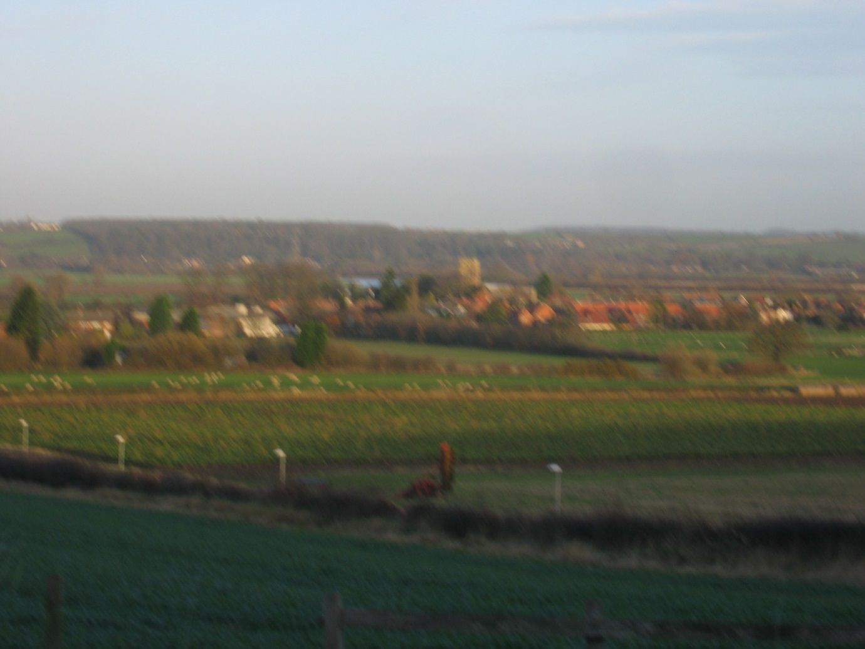
Shelford Church from the Top of the Hill

The Church tower of St Peter and St Paul at Shelford has been a landmark in the Trent Valley for centuries. Visible for miles around, it is now somewhat dominated by a new wind turbine at Stoke Bardolph from some aspects. The Church still serves a village of much the same physical size as in 1842 although its present population – some 280 - is only half of that in 1842 – 547 (with 140 at Newton) according to the 1841 Census. The story of its repair in 2016 illustrates, however, how much else has changed in the parish.
The church no longer plays the central role in the village community that it did up to and in the nineteenth century – and the stories of repair demonstrate this. In 1842, the Church as an institution, could enforce payment from the community towards maintenance and repair. In 2016, it is dependent on voluntary contributions, and it is fortunate that it retains a hold on the affection of those who live in Shelford (even if few attend its services). The contributions of the villagers to the Fabric Fund, as a community and as individuals, to enable the preservation of the Church building, a necessity for centuries, illustrate this. The way in which repair and maintenance are carried out, as well as how they are financed, also illustrate the manner of the major changes that have taken place in rural England.
The church repairs carried out in 1841-2 and in 2016 might seem very different, but the order of magnitude was probably similar – despite the massive differences in the formal total bills. Repair of the tower roof in 2016 cost about £28,000; the amount spent on the repairs of 1842 (some bills were not paid until the next year) was about £70. But this does not take account of a degree of inflation that is difficult to quantify, as different costs have changed in different ways. In 2016, the erection and maintenance of scaffolding cost £10,000; in 1842, the cost of putting up and taking down scaffolding was 5s (although the tower roof would be the most expensive possible location). Inter-temporal comparison is notoriously difficult, especially given technical change and improved labour remuneration, but the £70-80 or so spent then would not be a lot less than the cost in 2016. The major differences lie in who undertook the work and how it was paid for.
In 2016, a national firm, Norman & Underwood, specialising in church repairs, undertook the work on the tower roof and the Bell Chamber. In 1841 and 1842, the repairs were undertaken by a variety of local firms, most of them in the village itself. They were paid for essentially from the land, with farm occupiers paying virtually all that was required - however voluntarily is another question: agricultural prices were poor in 1842 at a time of an unpopular measure of tariff reform (anticipating the Repeal of the Corn Laws four years later). In 2016, the few farmers remaining are not even expected to pay community tax, let alone to support the church. Rather, the financial responsibility falls on the Parochial Church Council to raise money where it can. It is fortunate that, despite low attendances at services, the Church itself retains a strong hold on the affections of villagers – who have contributed handsomely to the cost of repairs.
The village community has thus played its part, in very different fashion, in both episodes in maintaining the church as a viable entity. In 2016, the question remains, as it did in the mid-nineteenth century, as to whether this will be enough in the face of declining attendances and continuing structural deterioration. In the nineteenth century, the principal landowner, the Earl of Carnarvon, came to the rescue. In the twenty-first century, it is evident that his successor, in the form of the Crown Estate, will not. Nevertheless, the position is not hopeless. Some answer will be found from an affluent society that values its heritage.

References
Bruce Bradley, 2013 Quinquennial Report for the Church of St Peter & St Paul, Shelford BB/30/10/2013.
Censuses of 1841 and 1851.
`The Churchwardens’ Accounts: Shelford Parish’, PR2866, Nottingham Record Office.
The Crown Estate Act 1961 at http://www.thecrownestate.co.uk/media/5305/crown-estate-act-1961-text.pdf.
Anne Digby, `The local state’ and `Social institutions’, G E Mingay, `Agricultural Taxes’ and John Fisher, `Agricultural Politics’ in E J T Collins, ed., The Agrarian History of England and Wales, Vol VII, 1850-1914, Cambridge University Press, 2000.
John Fisher, Victorian Vulpicide: A Hunting and Shooting Dispute in South Nottinghamshire' Transactions of the Thoroton Society, 105, 2001, pp.123-36.
The Illustrated London News, 20 August, 1842. I owe this reference to Roger Perrin.
John Jallands’ Notebooks and Loose Bills in Documents retrieved from a metal box in the Stanhope Chapel, Shelford Church, September 2015.
Geoffrey M. Morris, `Primitive Methodism in Nottinghamshire 1815-1932,’ Transactions of the Thoroton Society, 77, 1968, pp.81-101.
Pamela Priestland, A thousand years of Shelford and Newton, Echo Press, Loughborough, 2000.
Slater’s Royal National Commercial Directory of Nottinghamshire 1857 (Isaac Slater London 1857). Thanks to John Mills.
White’s Directories, 1853 and 1864.

